*Create a custom docker image for nginx and deploy it using docker compose, where the volume bind mount should be at /var/opt/nginx location. Push the created custom docker image to your docker-hub.*

Create a custom docker image for nginx and

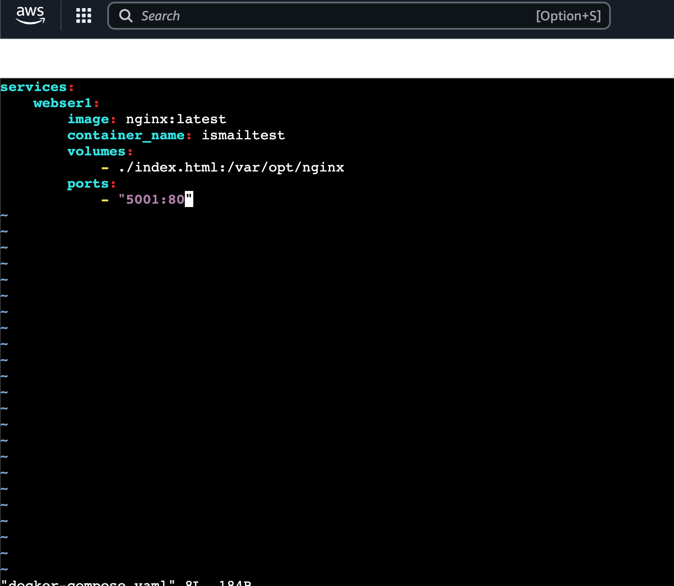

deploy it using docker compose

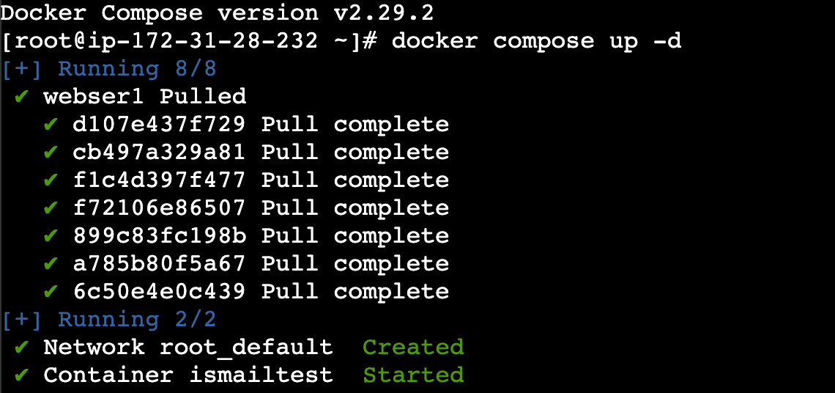

*where the volume bind mount should be at /var/opt/nginx location*

**

Logging to docker

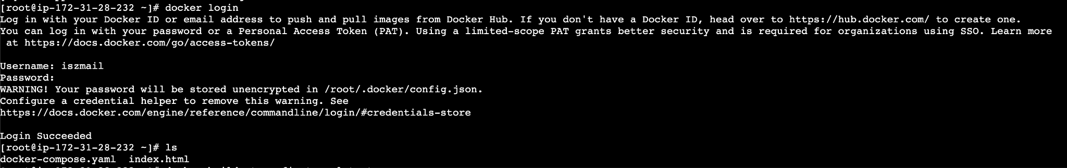

*Push the created custom docker image to your docker-hub.*

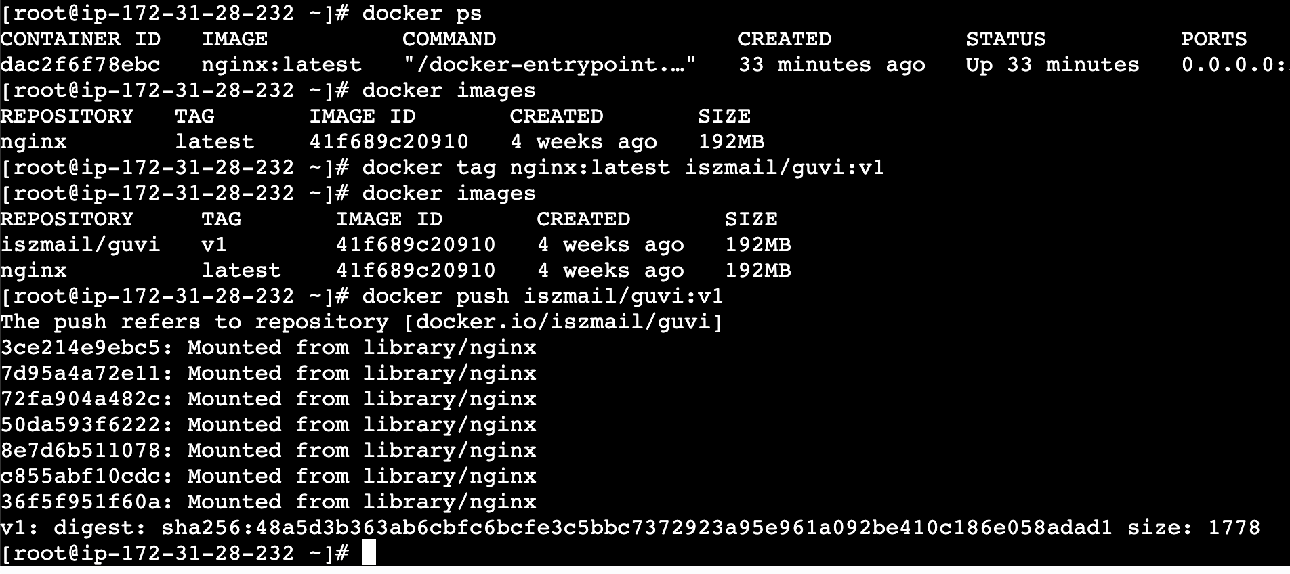

Pushed to the docker hub

